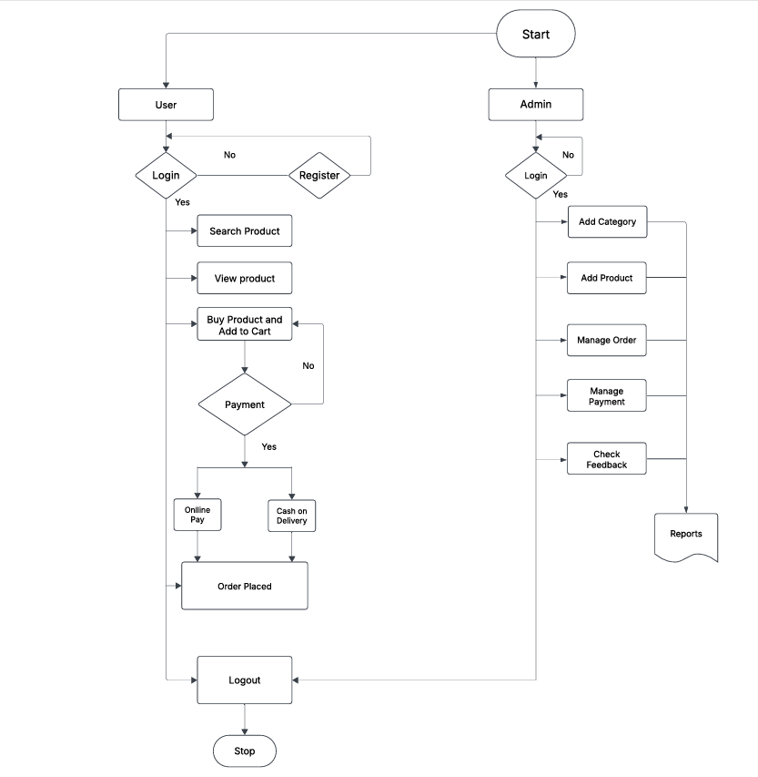

**Task analysis :** The process of studying user goals, actions, and workflows to design an intuitive interface. It involves breaking tasks into steps, identifying pain points, and optimizing usability for better user experience**.**

**User flow :** It refers to the path a user takes to complete a task within a system. It maps interactions step-by-step, ensuring a smooth and intuitive experience.

**User Flow:**

* Start → User decides to use the system.
* Login/Register → If not registered, the user must sign up.
* Search & View Products → User browses available products.
* Add to Cart & Buy → User selects items to purchase.
* Payment → Chooses between Online Pay or Cash on Delivery.
* Order Placed → If payment is successful, order is confirmed.
* Logout & Stop → User logs out after completing the purchase.

**Admin Flow:**

* Start → Admin accesses the system.
* Login → If valid credentials, admin proceeds.
* Manage Categories & Products → Admin adds/edit products.
* Order & Payment Management → Admin handles orders and payments.
* Check Feedback → Admin reviews customer feedback.
* Generate Reports → Admin processes reports for analysis.

|  |
| --- |